1. Scenario: You are working on a project that involves analyzing student performance data for a class of 32 students. The data is stored in a NumPy array named student_scores, where each row represents a student and each column represents a different subject. The subjects are arranged in the following order: Math, Science, English, and History. Your task is to calculate the average score for each subject and identify the subject with the highest average score.
Question: How would you use NumPy arrays to calculate the average score for each subject and determine the subject with the highest average score? Assume 4x4 matrix that stores marks of each student in given order.
Aim: To calculate the average score of each subject using NumPy and identify the subject with the highest average score.
Algorithm:
- Import the NumPy library.
- Create a 4×4 array containing student marks.
- Calculate the average of each subject using np.mean() with axis=0.
- Find the highest average using np.argmax().
- Display the averages and the subject with the highest average.

CODE:
import numpy as np
student_scores = np.array([
[85, 90, 78, 88],
[92, 85, 80, 75],
[78, 95, 88, 82],
[88, 80, 92, 90]
])
avg = np.mean(student_scores, axis=0)
subjects = ["Math", "Science", "English", "History"]
print("Average scores:", avg)
i = np.argmax(avg)
print("Highest average subject:", subjects[i])
print("Highest average:", avg[i])
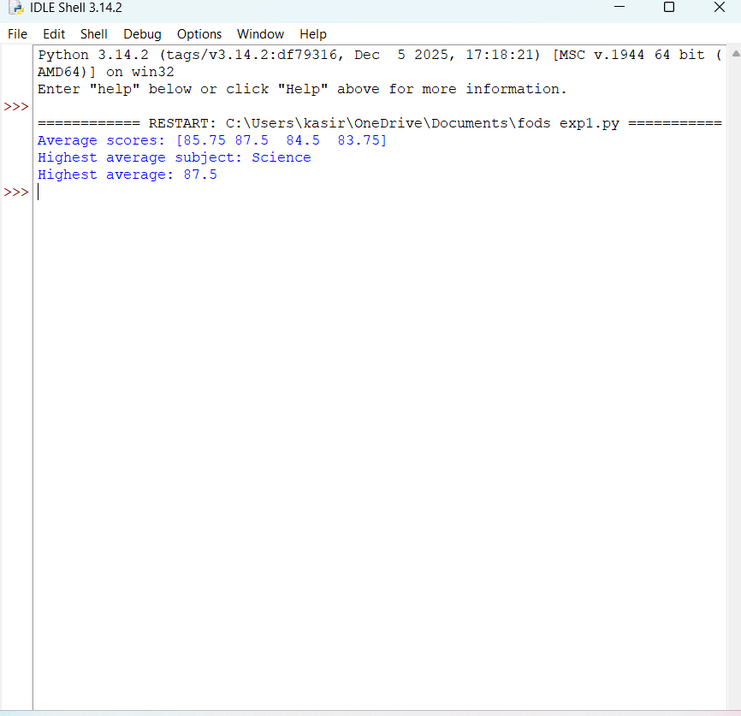
OUT PUT:

Result: Science has the highest average score of 87.5 marks.

